# Queries

MariaDB [hr]> show tables;

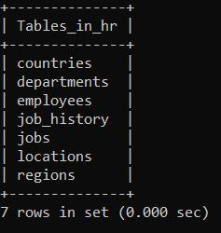

MariaDB [hr]> desc jobs;

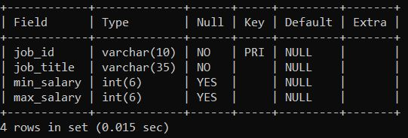

MariaDB [hr]> select * from jobs;

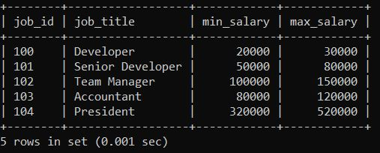

MariaDB [hr]> desc regions;

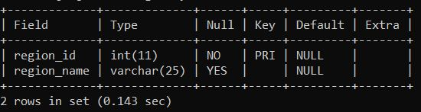

MariaDB [hr]> select * from regions;

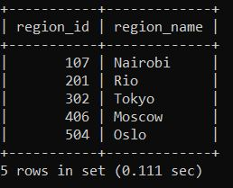

MariaDB [hr]> desc countries;

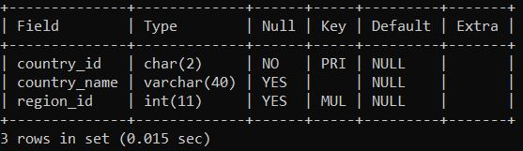

MariaDB [hr]> select * from countries;

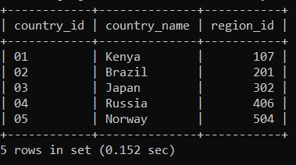

MariaDB [hr]> desc locations;

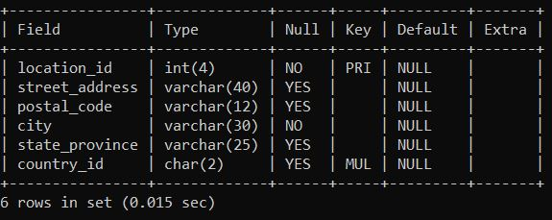

MariaDB [hr]> select * from locations;

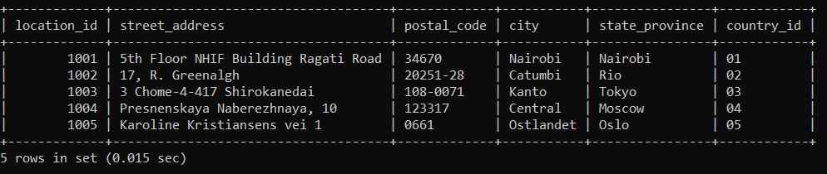

MariaDB [hr]> desc departments;

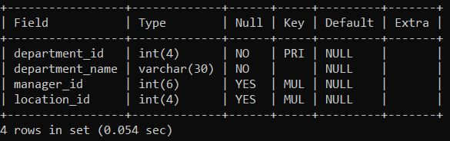

MariaDB [hr]> select * from departments;

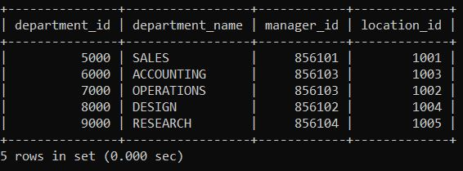

MariaDB [hr]> desc employees;

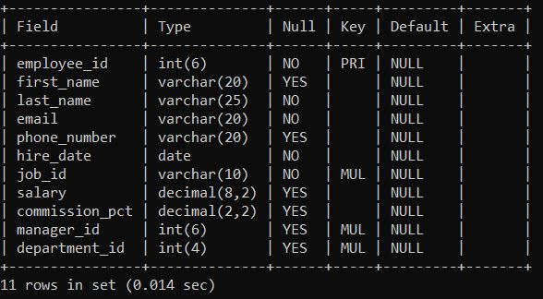

MariaDB [hr]> select * from employees;

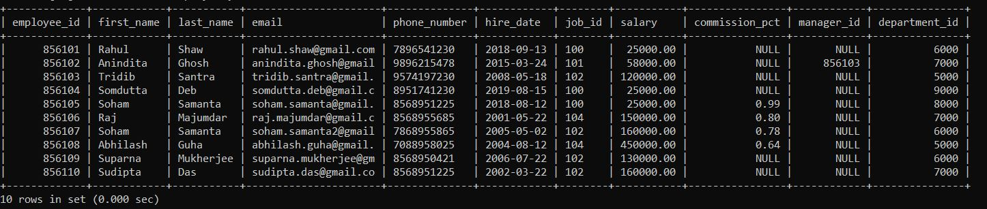

MariaDB [hr]> desc job_history;

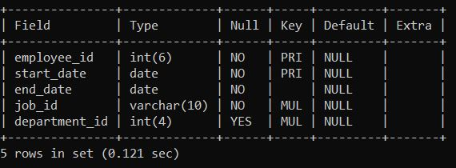

MariaDB [hr]> select * from job_history;

